**Convolution Neural Networks (CNN)**

**Instructions:**

Please share your answers filled in-line in the word document. Submit code separately wherever applicable.

Please ensure you update all the details:

**Name: _____________ Batch ID:** ___________

**Topic: Convolutional Neural Networks**

**Guidelines:**

**1. An assignment submission is considered complete only when the correct and executable code(s) and documentation explaining the method and results are submitted. Failing to submit either of those will be considered an invalid submission and not a correct submission.**

**2. Ensure that you submit your assignments correctly and in full. Resubmission is not allowed.**

**3. Post the submission you can evaluate your work by referring to the keys provided. (will be available only post the submission).**

**Hints:**

1. **Business Problem**
   1. **What is the business objective?**
   2. **Are there any constraints?**
2. **Work on each feature of the dataset to create a data dictionary as displayed in the below image:**

**Make a table as shown above and provide information about the features such as its data type and its relevance to the model building. And if not relevant, provide reasons and a description of the feature.**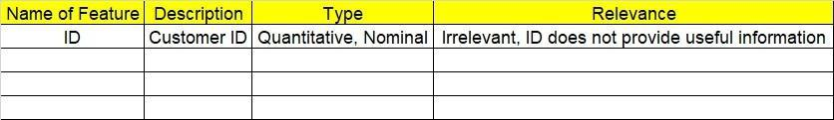

1. **Data Pre-processing**

**3.1 Data Cleaning, Feature Engineering, etc.**

**3.2 Outlier treatment if applicable.**

1. **Model Building**
   1. **Build a convolution neural network model.**
   2. **Train and test the model.**
   3. **Briefly explain the model output in the documentation.**
2. **Write about the benefits/impact of the solution - in what way does the business (client) benefit from the solution provided?**
3. **Use Tensorflow for this assignment. Depending on your system configuration, either Tensorflow GPU or Tensorflow CPU versions.**

**Problem Statement: -**

1. Build a CNN model on the CIFAR-10 dataset by applying a few regularization techniques like dropout and data augmentation. Download the data set from a library called tensorflow. Finally do the deployment on streamlit application
2. Find out the differences between the Convnet filter and the Maxpool layers.
3. If the input of an image is 64x64x3 which has been convolved by 10 5x5 filters with stride 1 and padding 2:
4. How many activation maps are obtained?
5. What is the size of the activation maps?
6. How many parameters are calculated?
7. What are the different techniques that need to be applied to overcome the issue of overfitting? Provide brief explanations of how these techniques address the issue.